How to Update SEC-E9 key cutting machine

----For 8″ inch Tablet PC version
New customers need to register to Hunan kukai’s membership system first.
Old customers please login the membership system.

How to upgrade:
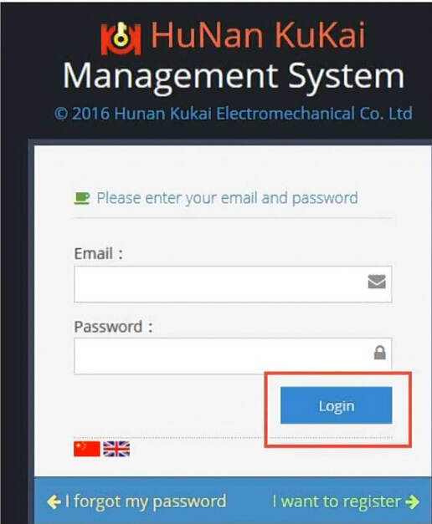
Login to membership system.
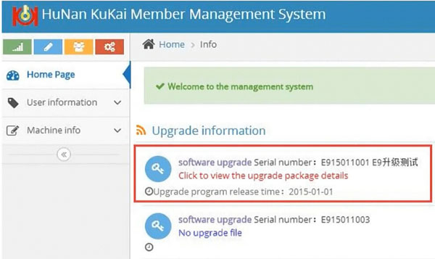
Check upgrade information and latest database available
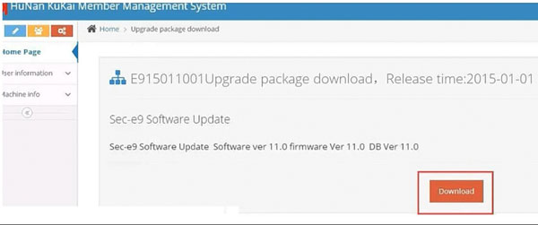
Download database to your computer
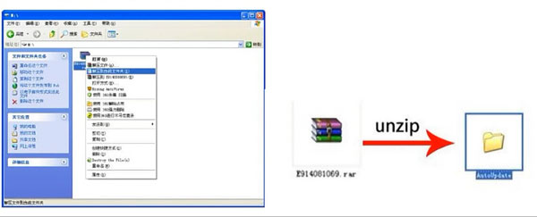
Unzip database
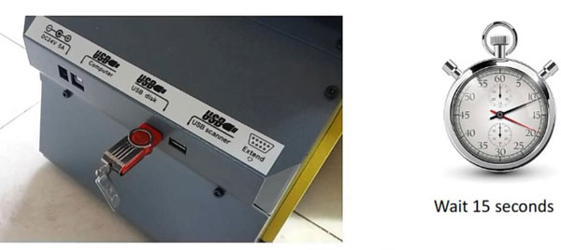
Insert USB disk with database to SEC-E9 key cutting machine
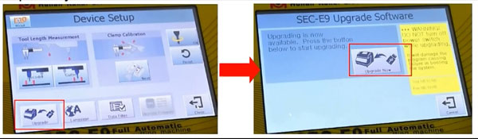
Go to Device setup->Upgrade
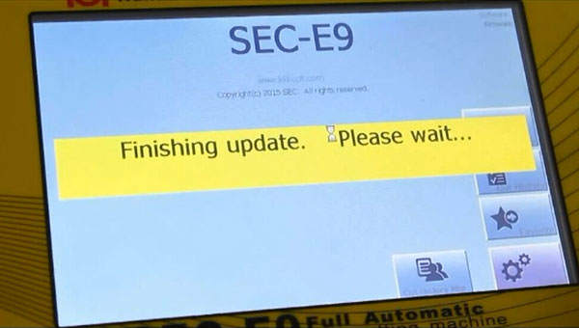
Wait until upgrade is finished.

How to upgrade SEC-E9 key cutting machine?

—for Tablet PC Bluetooth Version
1. Click ”Setup”
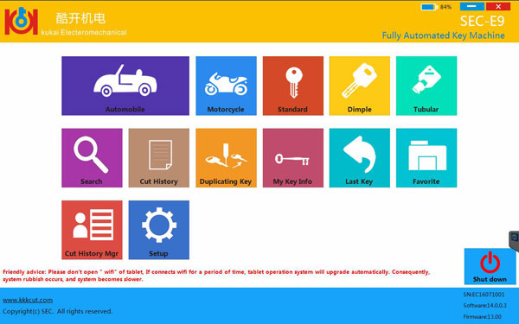
2. Click”Wifi”
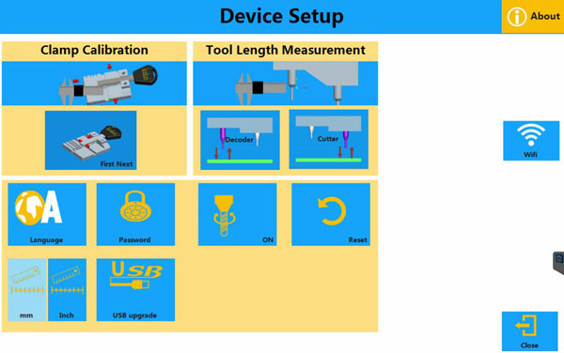
3. Connect Wifi
4. Press ”UpdateCheck” after the wifi is connected successfully.
( Please notice that you just need to click the ”UpdateCheck” once, no need to click it repeatedly)
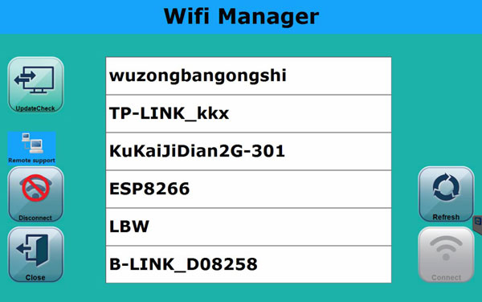
5. Click ”Upgrade” button
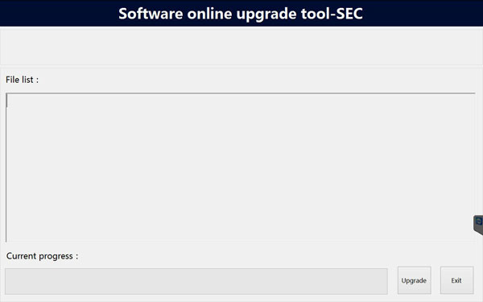
6. After upgrading successfully, the tablet PC will automatically jump to the main page.
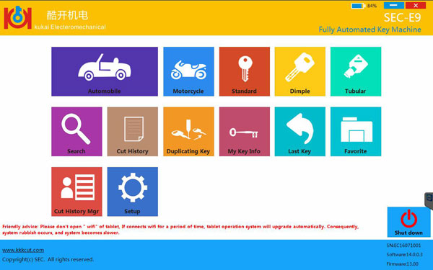
Notice
1. Please keep the Wifi connected when upgrade
2. Please keep the network smooth
3. Please do not turn off tablet PC when upgrading
4. Please do not operate the tablet PC when downloading the upgrade files.
5. Please disconnect Wifi after upgrade is done. ( otherwise the system will generate garbage when tablet PC updates automatically . Also cause the system to run slowly.)

