Toyota Lexus - Smart key - All key lost - Helps
Applied to ：DST80“98”--the Green smart key emulator

This help file basically includes 4 parts: Function, Operation, Attention, and
Reference.

Functions
Operational process for all key lost
Please confirm whether emulator key (SKE) is bound to K518 device beforehand.
Backup EEPROM data-> Generate new data-> Dismantle immo box and write
new data to EEPROM-> Generate SKE-> Add/delete smart key

1. Backup original EEPROM immo data.
2. Use backup data to generate new data.
3. System certify and generate new data automatically, and program SKE to become an available key, which can open dashboard, before key programming.
4. Add a smart key.
5. Delete programmed key.
6. Bind emulator key: Require to bind all SKE to K518 for the first use.

Operation
Operational process for all key lost
Please confirm whether K518 is bound to emulator key (SKE).
Backup EEPROM immo data-> Generate new data-> Dismantle immo box and
write new data to EEPROM-> Generate SKE-> Add/delete smart key

Backup EEPROM data
- This function can backup EEPROM data.
- System is receiving data, please wait patiently.
- Please input data filename and save succeed.
- EEPROM data backup complete, please select “generate EEPEOM data”
function to generate specific data.

Generate EEPROM data
- This function can generate EEPROM data for vehicle.
- Continue to select EEPROM data of smart key backed up before.
- Searching data... Please input filename of new data.
- Generating EEPROM data complete. Data saved in K518\file\feature_1013.
Please write newly-generated data to EEPROM（IC003）in smart immo box of
vehicle. More details, refer to “Reference”.

89990-0N010 smart immo box (see below pic)
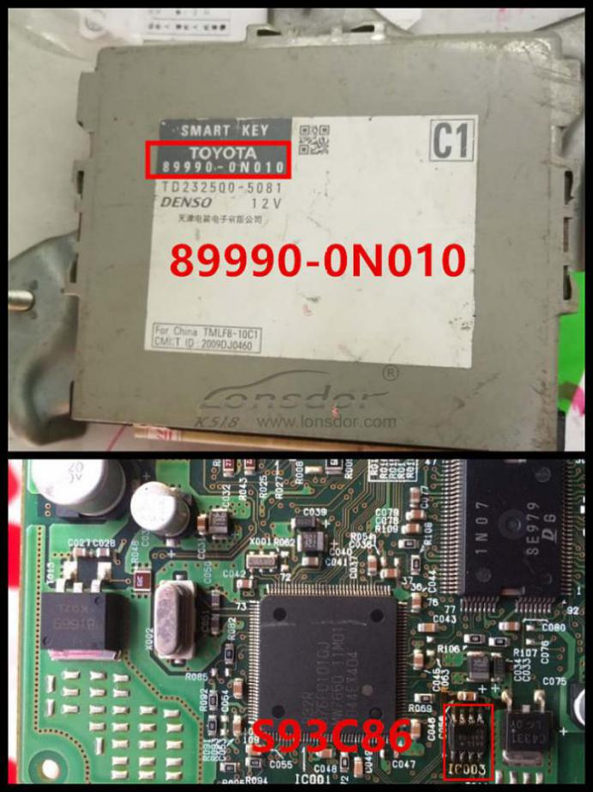
89990-06060smart box(see below pic)
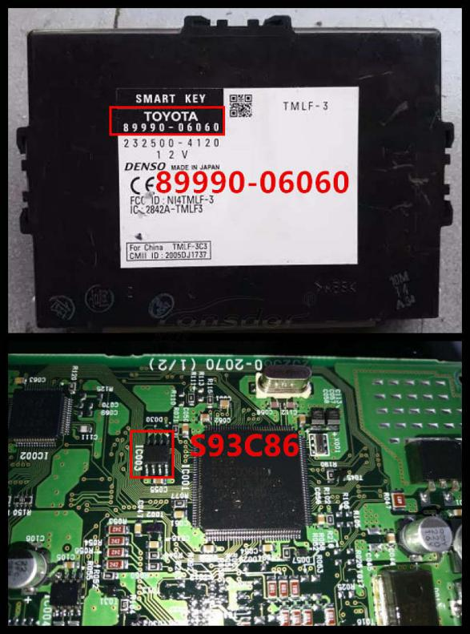M
Note: Install back smart box when data writing complete.

Generate emulator key
It's required to write newly-generated data to EEPROM in smart immo box.
Dashboard is lit up after emulator key (SKE) generated.
- This function can generate a backup master key when all keys are lost, which
can open dashboard to add keys.
2. Insert bound SKE(corresponding color/type) into K518 card slot, and press
round button on the key.
3. System is building configuration... Please wait patiently.
4. Key generation complete. Please press round button on it and put it against
ignition switch of vehicle, and try to open dashboard. If the dashboard is lit up,
please use SKE to program and add new keys.

Add smart key
- Put emulator key or available key against ignition switch and switch ignition ON
till dashboard is lit up.
2. System communication, getting info about key numbers...
3. Put registered smart key against start button of vehicle, and remove it when
buzzer beeps once.
- Please put smart key to be registered at start button of vehicle in 30 seconds,
and remove it when buzzer beeps twice.
5. Please wait till key registration complete. Operation succeed.

Delete smart key
- Put emulator key or available key close to ignition switch and switch ignition
ON till dashboard is lit up.
2. System communication, getting key numbers...
3. Put back of registered smart key close to vehicle start button, and remove it
when buzzer beeps once.
- System is deleting key... Deleting succeed. Smart key (away from start button)
will be deleted.

Bind emulator key
1. This function can bind smart key emulator (SKE-LT series) to K518 host.
2. Please put key to be bound into K518 host slot.
3. System is binding... When complete, continue to program all keys lost.
Attentions
- Newly-generated data must be written to EEPROM chip in smart box.
Dashboard can be lit up after simulate key is generated.
- Bind key/generate key: Change placement of simulate key to sense if failed.
98 card smart box is located at back of storage box at passenger seat.
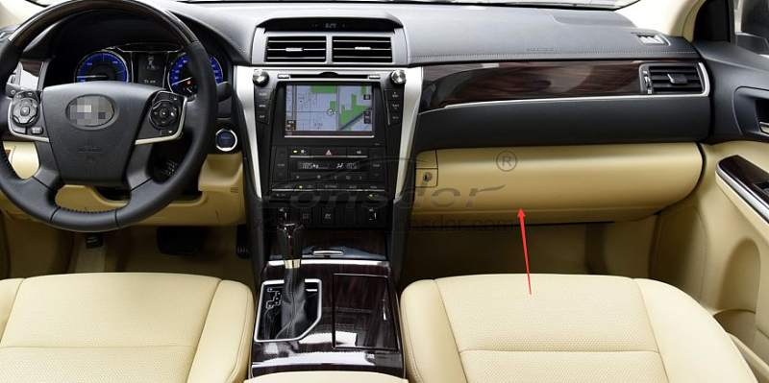
Reference

Chip type | 94/D4(SKE black), 88/A8(SKE red), A9(SKE blue), 39(SKE orange)
Remote control type | Specific smart key
Key embryo No. | Specific smart key
Password required or not | Not required.
Remote control | Generate automatically when smart key programming complete.
OBD position | Under steering wheel
Reference pics | Smart key appearance for part of Toyota series  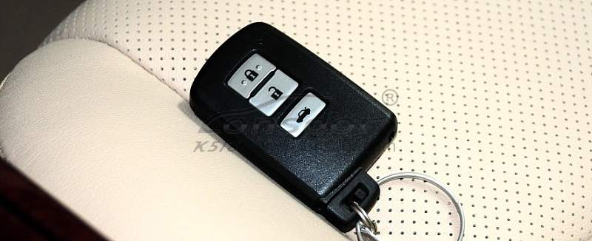  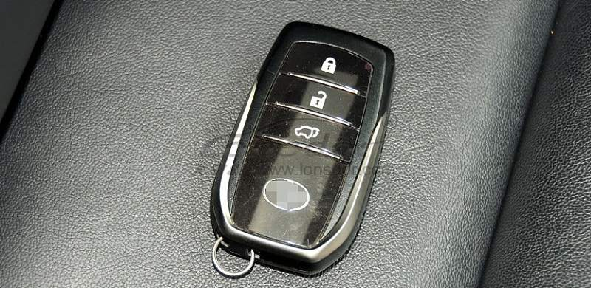  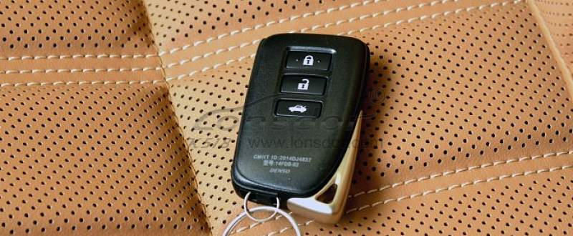  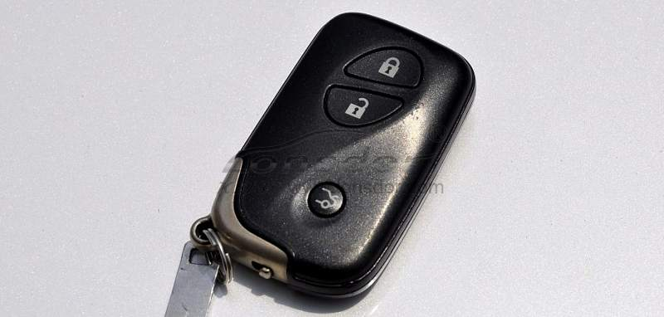  Toyota series：  2008 Reiz 0111 smart key  2008 RAV4 0111 smart key  2008 Prado 0140 smart key  2008 Camry 0140 smart key  2008 Corolla 0111 smart key  2008 Cruiser A433 smart key  2008 Alfa smart key  2008 Previa smart key  2008 Lexus 0140 smart key  2010 Camry 3370 smart key  2010 Prado 3370 smart key  2010 Reiz 5290 smart key  2010 Crown 5290 smart key  2010 Lexus 3370 smart key  2010 Camry 0020 smart key  2012 Reiz 7930 smart key  2012 Crown 7930 smart ky  2012 Prado 7930 smart key  2012 RAV4 7980 smart key  2013 Lexus ES GS IS smart key  2014 RAV4 2-button smart key  2014 RAV4 3- button smart key  2014 New vios/Yaris L smart key  Lexus smart key，select from PCB type：  89904-30291（0140 PCB ES350 old ver. )  89904-50430（3370 PCB ES240/ES350 new ver.）  89904-48321 (5290 PCB PX270）  89904-28132（0780 PCB 5-button Previa）  89904-6071 （A433 PCB Cruiser）  89904-0041(0111PCB RAV4 3-button Reiz Carola)

